

Practices for Secure Software Report

Table of Contents
Document Revision History 3
Client 3
Instructions 3
Developer 4
1. Algorithm Cipher 4
2. Certificate Generation 4
3. Deploy Cipher 4
4. Secure Communications 4
5. Secondary Testing 4
6. Functional Testing 4
7. Summary 4
8. Industry Standard Best Practices 4

Document Revision History

Version | Date | Author | Comments
1.0 | 2/22/26 | Daniel Norman

Client



Instructions

Submit this completed practices for secure software report. Replace the bracketed text with the relevant information. You must document your process for writing secure communications and refactoring code that complies with software security testing protocols.

- Respond to the steps outlined below and include your findings.
- Respond using your own words. You may also choose to include images or supporting materials. If you include them, make certain to insert them in all the relevant locations in the document.
- Refer to the Project Two Guidelines and Rubric for more detailed instructions about each section of the template.

Developer
Daniel Norman

Algorithm Cipher

AES-256 with SHA-256 and TLS 1.2/1.3

High-Level Overview

- AES-256 for symmetric encryption
- SHA-256 for checksum verification
- TLS 1.2 or TLS 1.3 for secure HTTPS communication
- RSA 2048+ for certificate-based asymmetric key exchange

AES is the industry-standard symmetric encryption algorithm used by financial institutions, government systems, and enterprise web applications (Cooper, 2025).

Hash Functions and Bit Levels

SHA-256

- Produces a 256-bit hash value
- One-way cryptographic hash function
- Resistant to collision and preimage attacks

AES-256

- 256-bit key length
- Block cipher 128-bit blocks
- Resistant to brute-force attacks

Use of Random Numbers

Random numbers are used to generate secure encryption keys and other cryptographic values. They must be unpredictable, so secure generators like Java’s SecureRandom are used instead of basic random functions. Strong randomness helps prevent attackers from guessing keys.

Symmetric vs. Non-Symmetric Keys

Symmetric encryption uses one shared key for both encryption and decryption and is fast and efficient (geeksforgeeks, 2025). Asymmetric encryption uses a public and private key pair and is commonly used for secure key exchange in HTTPS (geeksforgeeks, 2025).

History and Current State of Encryption

Older algorithms like DES and SHA-1 are no longer secure. Modern systems use AES-256 and SHA-256, along with TLS 1.2 or 1.3, which are current industry standards for protecting sensitive data.

Certificate Generation
Insert a screenshot below of the CER file.

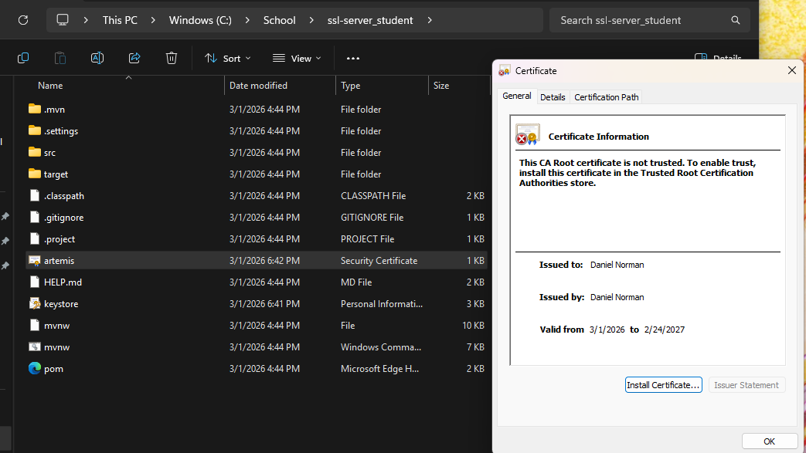
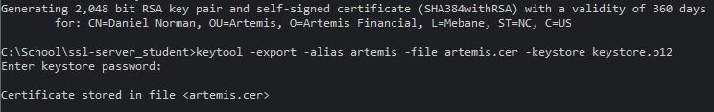

Deploy Cipher
Insert a screenshot below of the checksum verification.

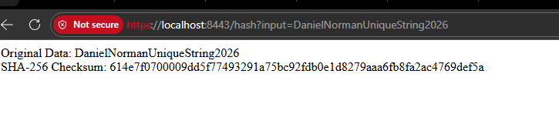

Secure Communications
Insert a screenshot below of the web browser that shows a secure webpage.

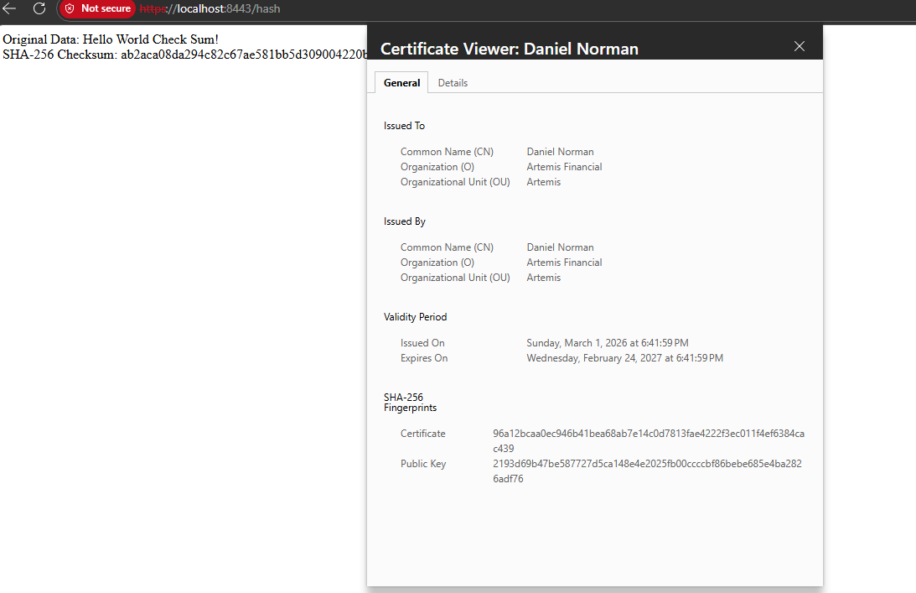

Secondary Testing
Insert screenshots below of the refactored code executed without errors and the dependency-check report.

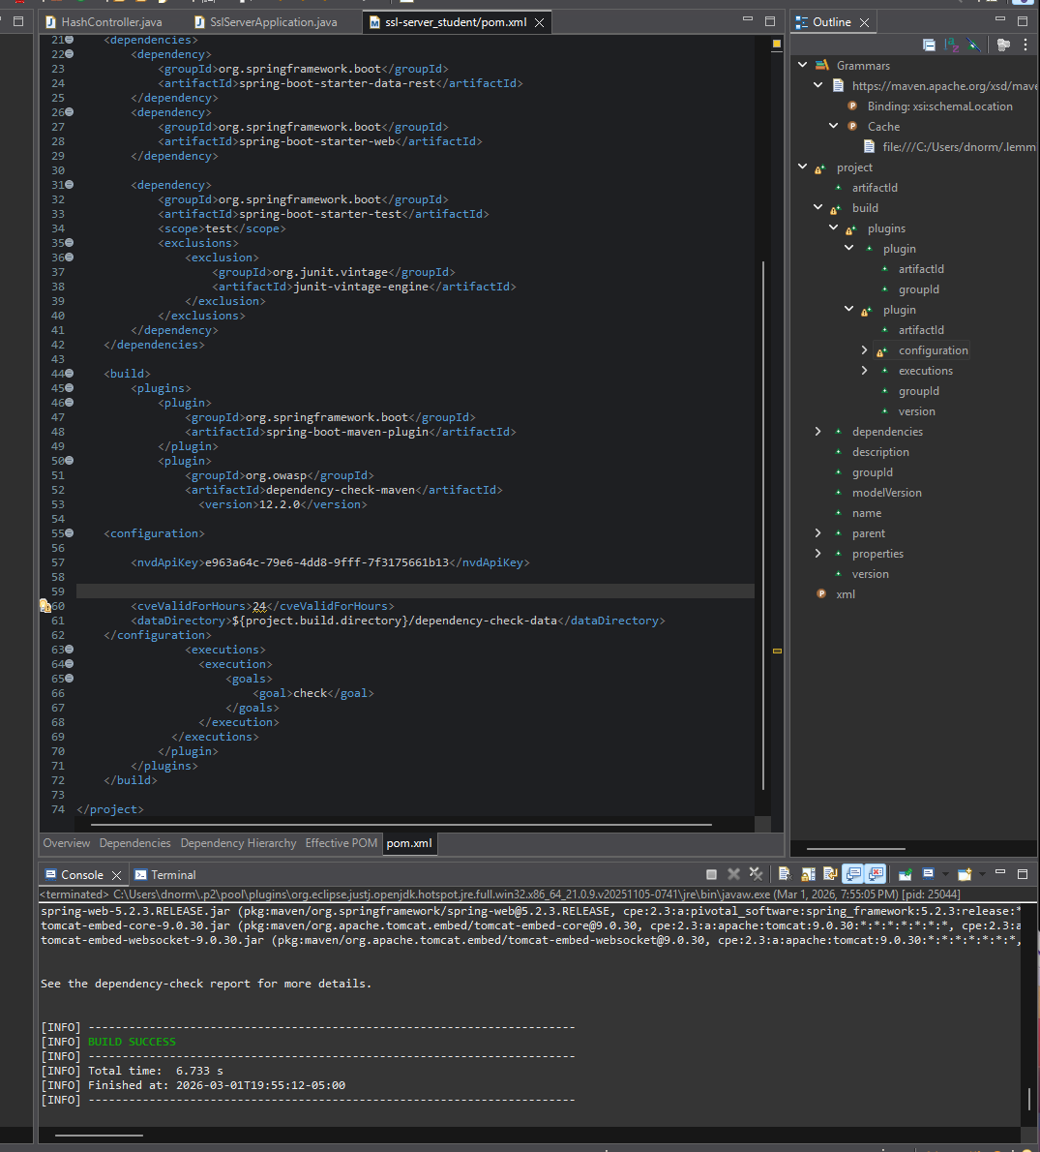
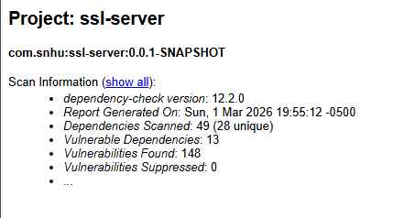

Functional Testing
Insert a screenshot below of the refactored code executed without errors.

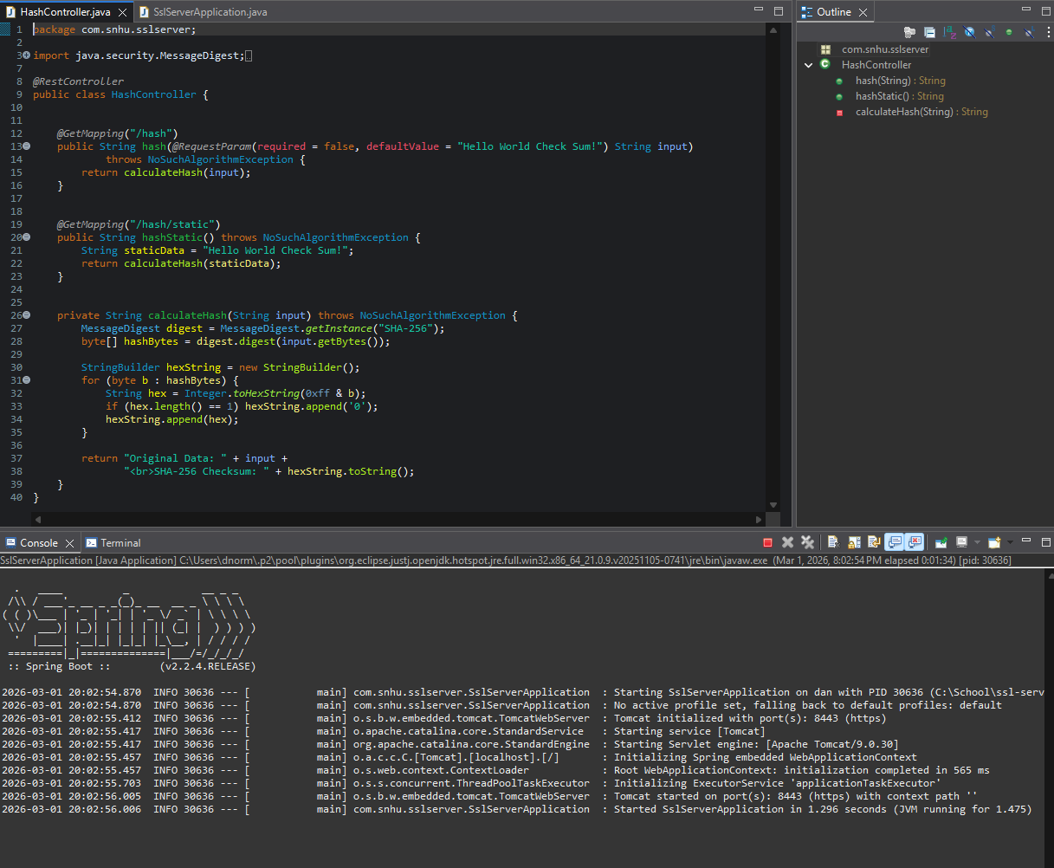

Summary

Refactoring and Vulnerability Assessment Areas Addressed
Based on the vulnerability assessment process flow diagram, the refactoring focused on architecture review, cryptography, client/server security, input validation, code quality, and secure error handling. HTTPS was implemented to secure client/server communication, which strengthens encryption and protects data in transit. Input handling was improved to prevent bad requests, and secure coding practices were followed to reduce common vulnerabilities. These updates align with the diagram’s focus on secure configuration, encryption use, and proper code review practices.

Process for Adding Layers of Security
Security was added in layers to better protect the application. First, SSL/TLS encryption was configured to secure communication. Next, HTTP traffic was redirected to HTTPS to prevent insecure access. Input validation was improved to reduce user input errors, and hashing with SHA-256 was used to protect data integrity. By applying multiple protections instead of relying on just one, the application is more secure against different types of threats.

Industry Standard Best Practices

Maintaining Existing Security with Best Practices
Industry standard best practices were used to maintain and improve security. HTTPS and SSL/TLS were implemented to follow modern web security standards. SHA-256 was used as a strong, accepted hashing algorithm. Secure coding practices, such as proper configuration and structured error handling, helped reduce vulnerabilities while keeping the application stable and functional.

Value of Secure Coding to the Company
Applying industry standard secure coding practices helps protect sensitive information and reduces the risk of cyberattacks. Strong security lowers the chances of data breaches, financial loss, and damage to the company’s reputation. It also builds customer trust and ensures the software meets professional and regulatory standards. Overall, secure coding supports the company’s long-term success and reliability.

References

Cooper, V. (October 8, 2025). AES Encryption Explained: How it works, benefits, and real-world uses. Splashtop. https://www.splashtop.com/blog/aes-encryption

Geeksforgeeks. (July 12, 2025). Difference between symmetric and asymmetric key encryption. GeeksforGeeks. https://www.splashtop.com/blog/aes-encryption

